**INPUT**

<?php

session_start(); //start the PHP_session function

if(isset($_SESSION['page_count']))

{

$_SESSION['page_count'] += 1;

}

else

{

$_SESSION['page_count'] = 1;

}

echo 'You are visitor number ' . $_SESSION['page_count'];

?>

**OUTPUT**

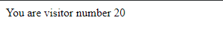



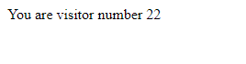

**INPUT**

<?php

$cookie_name = "user";

$cookie_value = "Reignz";

setcookie($cookie_name, $cookie_value, time() + (86400 * 30), "/"); // 86400 = 1 day

?>

<html>

<body>

<?php

if(!isset($_COOKIE[$cookie_name])) {

echo "Cookie named '" . $cookie_name . "' is not set!";

} else {

echo "Cookie '" . $cookie_name . "' is set!<br>";

echo "Value is: " . $_COOKIE[$cookie_name];

}

?>

</body>

</html>

**OUTPUT**

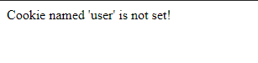

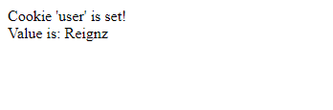

**INPUT**

<?php

// set the expiration date to one hour ago

setcookie("user", "", time() - 3600);

?>

<html>

<body>

<?php

echo "Cookie 'user' is deleted.";

?>

</body>

</html>

**OUTPUT**

